**Project Final Phase**

**Testing and Test Automation in Game Development**

**Appium and AltUnity/Altester**

19L-2254

19L-1132

Open source Project Cloned: <https://github.com/alttester/EXAMPLES-Java-Standalone-and-Android-AltTrashCat.git>

Project Setup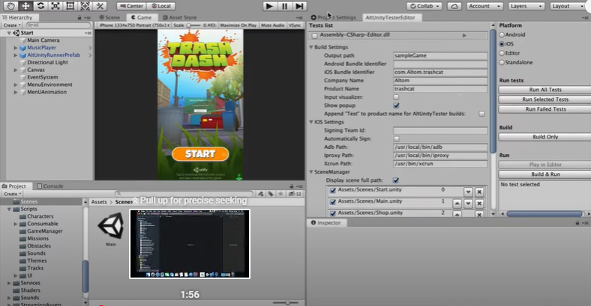

Open the project and select build only. Then the project will be created and using XCode open the project.

Make sure your device is set as target

Go to signing and capabilities and tick the automatically manage signing box

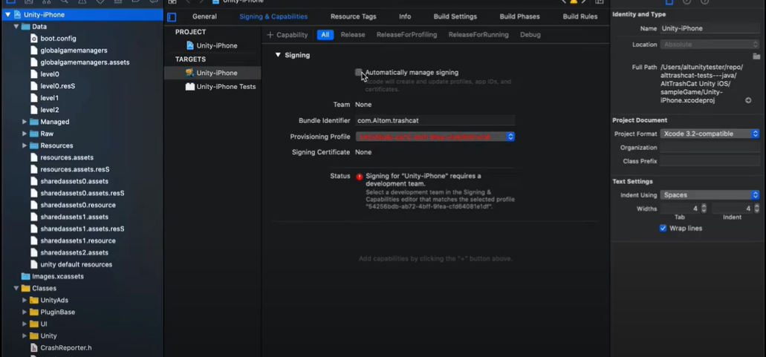

Go to build setting and select the IOS or Android developer option according to your device

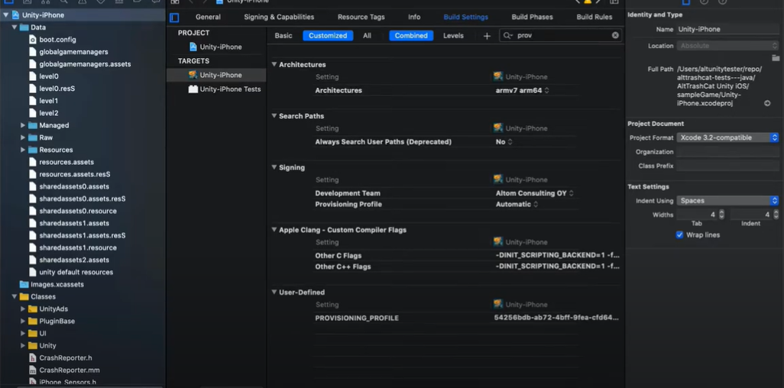

Now use terminal and execute command ./launch-IOS-game.sh



And select the identifier of your device list from target list

Now the written test in java will be executed on your app automatically!

Runed tests are shown in a small video tutorial!